How to connect another remote desktop protocol (RDP) in our system using Linux (Ubuntu) server commands.

First we create an instance.

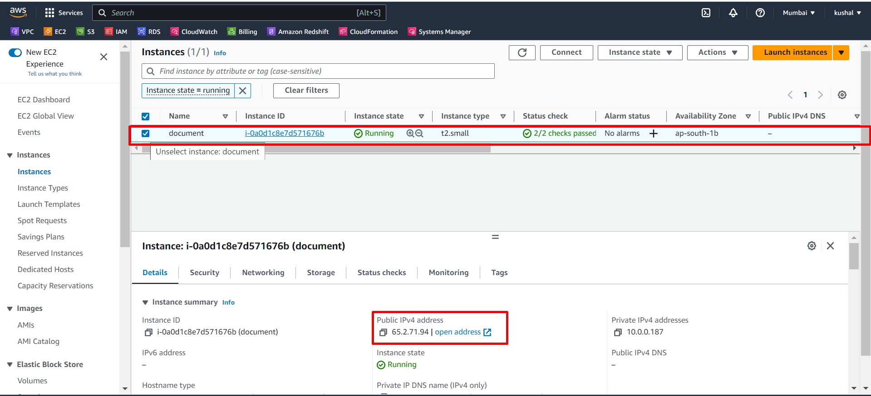

Next connect that server using public IP.

Here we connect to mobaxterm (public IP – server username- pem key).

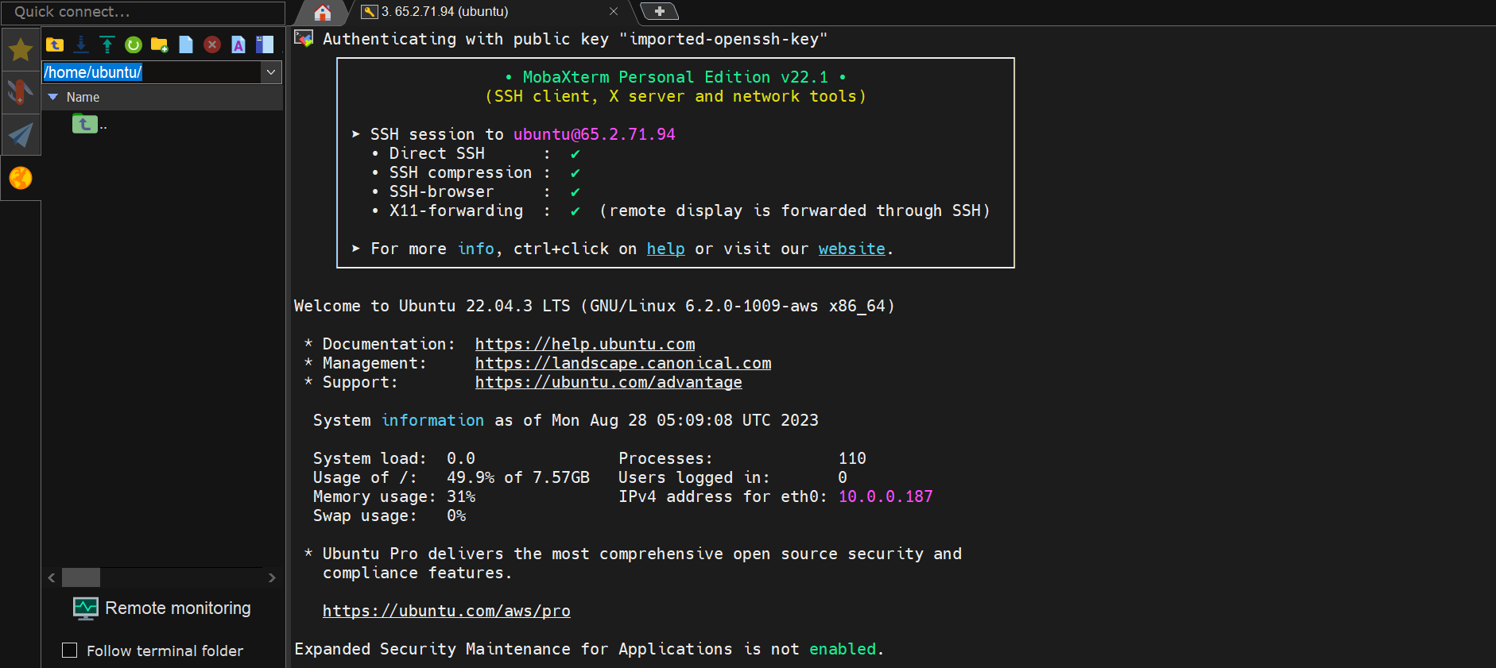

After that we using this command for connecting remote desktop protocol.

Commands: -

sudo apt update

sudo apt install xrdp

sudo systemctl enable xrdp

After successfully installed and enable xrdp.

Next we go to search bar in system and enter “remote desktop connection”

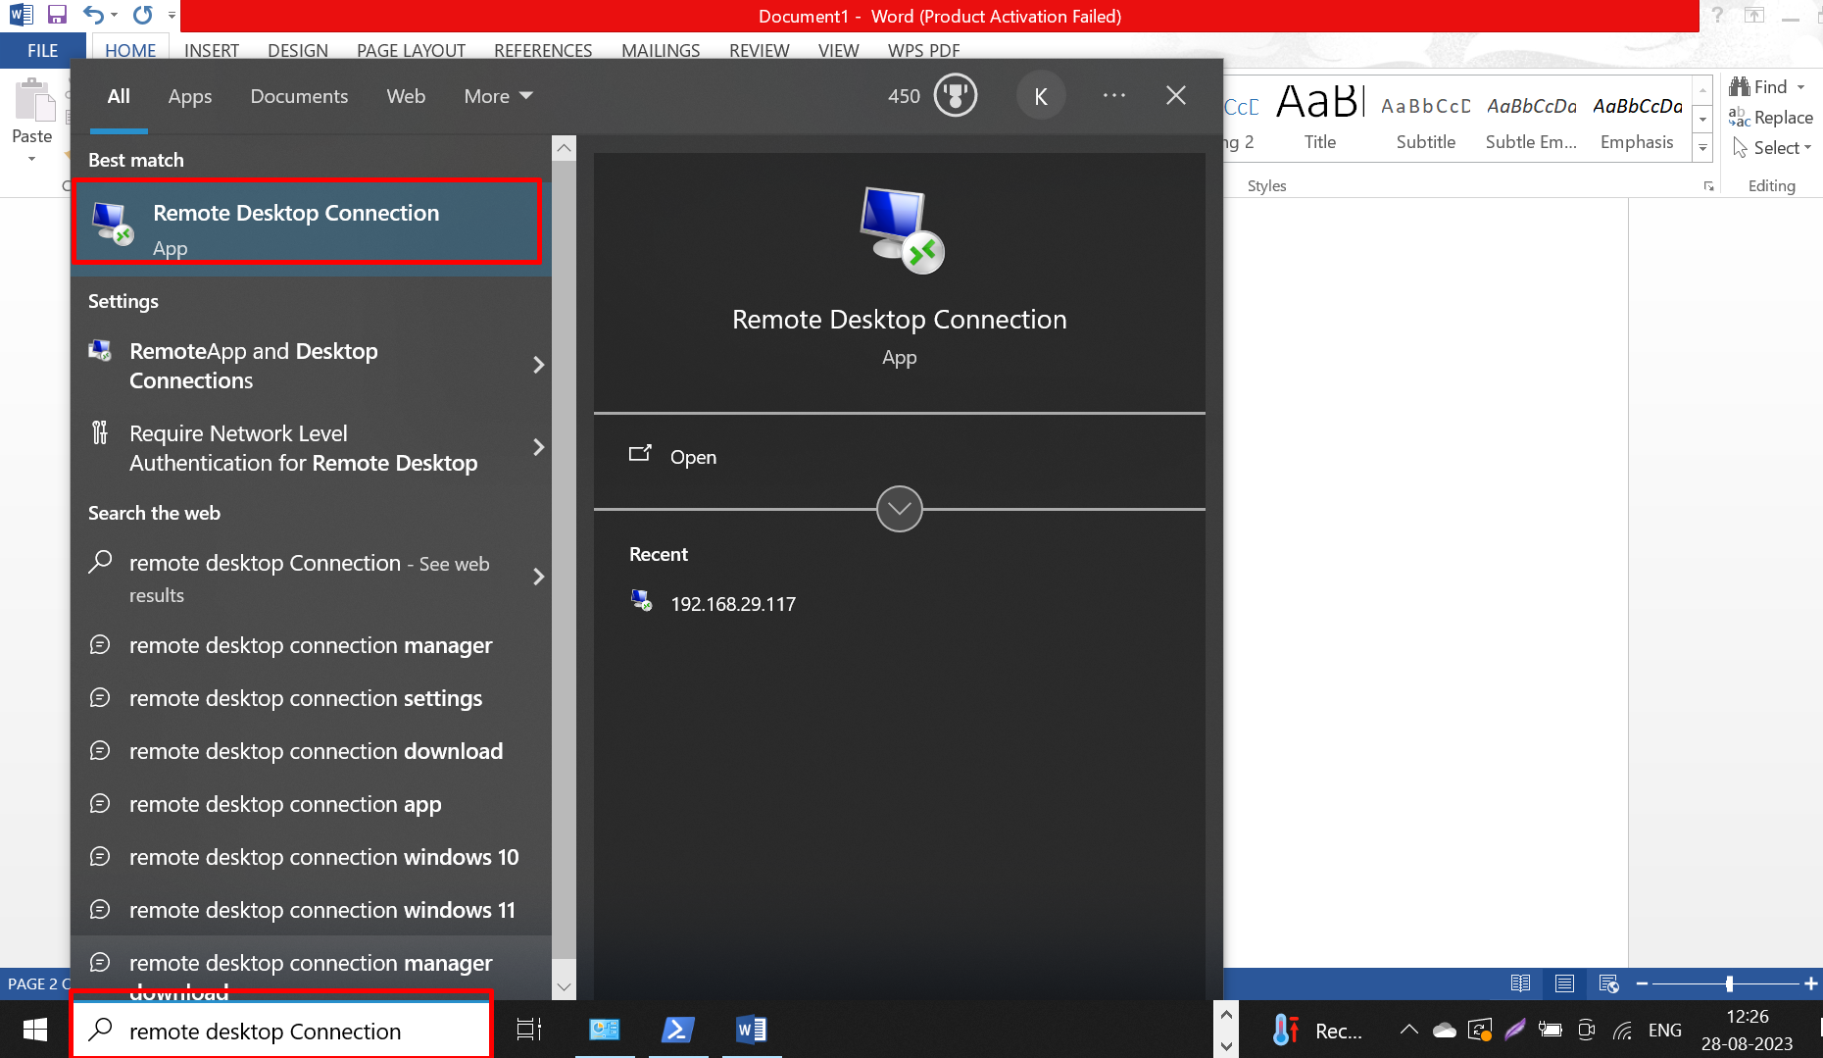

Next select that.

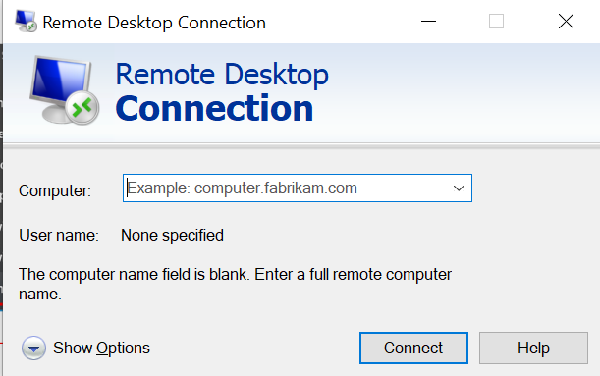

Now we enter another system IP address and select connect and also enter that system username and password finally enter connect. Here I already connected that system for this reason it don’t show username and password for me.

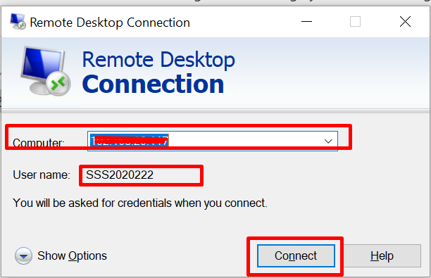

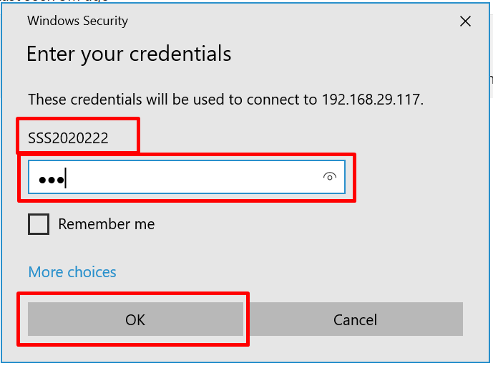

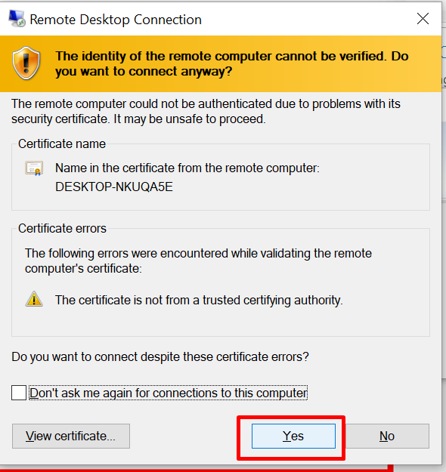

We successfully connected another remote desktop in our system using Linux (Ubuntu) server.

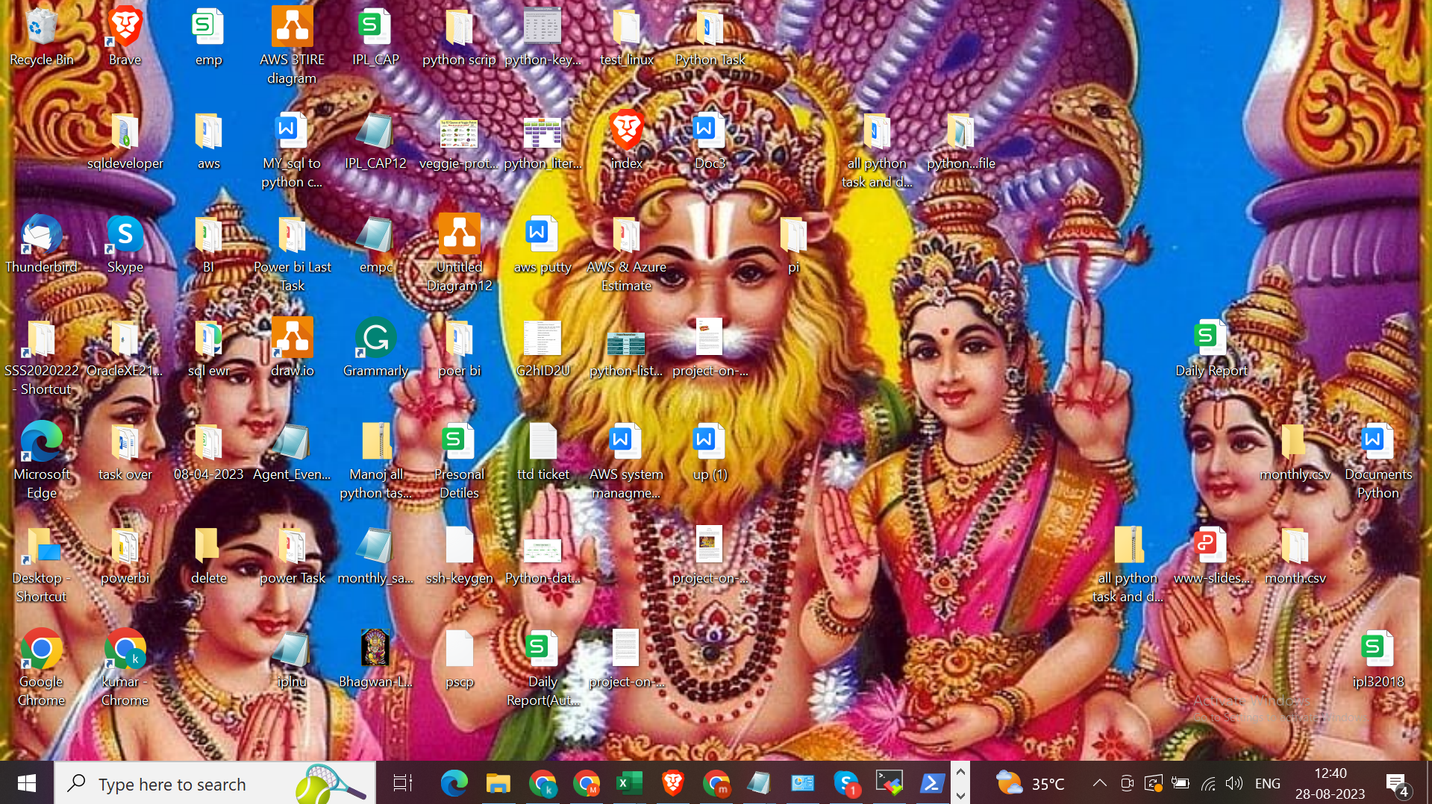

**THANK YOU**